QUESTION 1

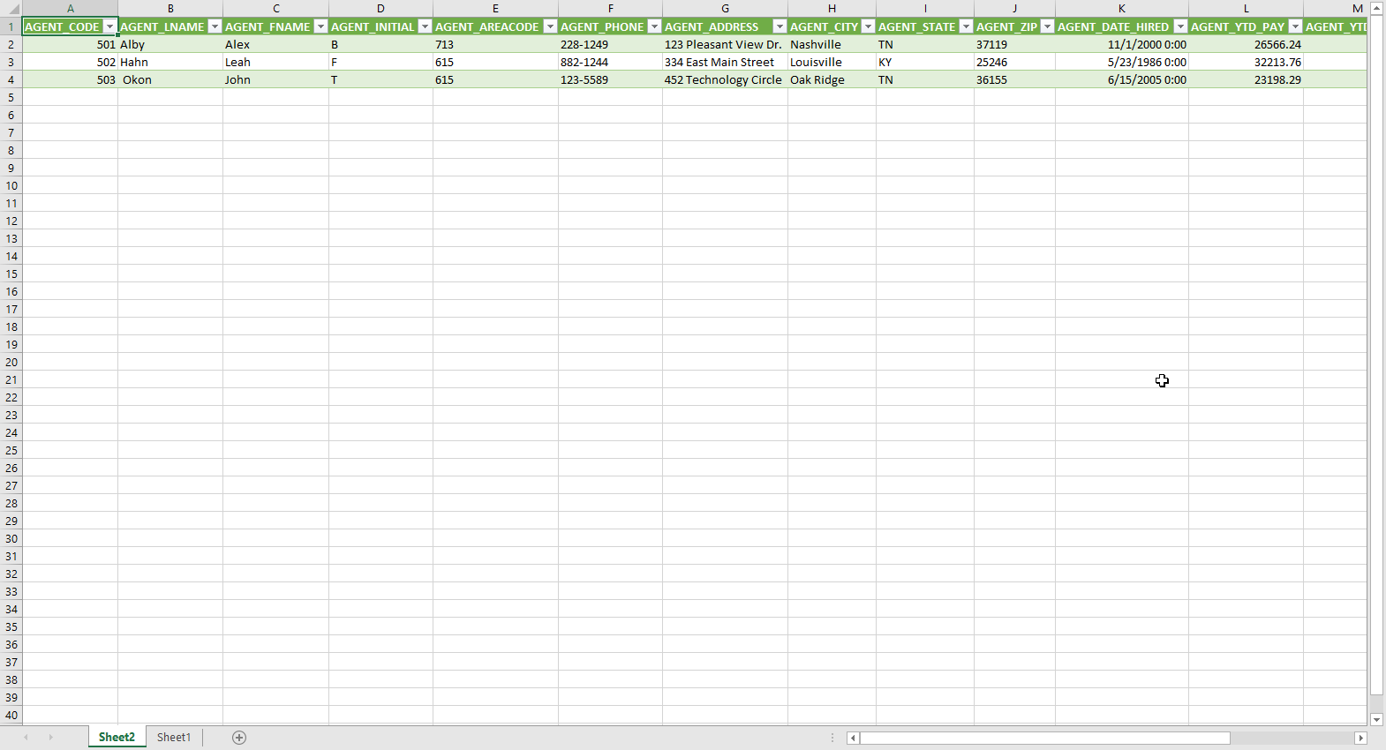

QUESTION 4

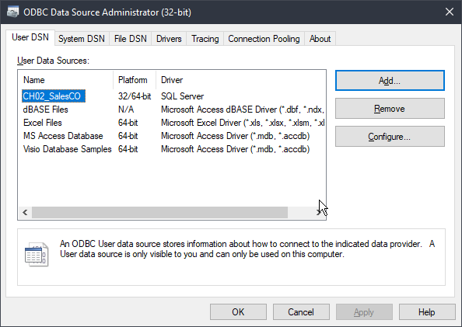

QUESTION 5 (can’t do it because the option for Microsoft query isn’t available )

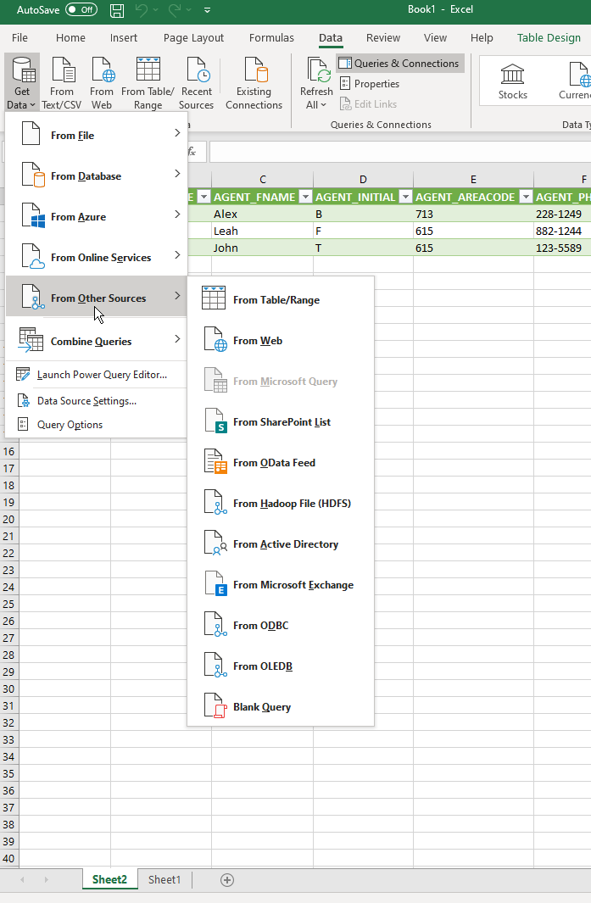

QUESTION 9



PART 2

Other problems are in the lab7 sql file.